Assumptions Made - 4 -
ER Model Diagram - 4 -
List of mapped Relations (Logical Design) - 4 -
Data Dictionary - 5 -
HawkerCentre - 5 -
FoodStall - 5 -
StallOwner - 5 -
Complaint - 6 -
Customer - 6 -
Feedback - 6 -
Likes - 7 -
CustOrder - 7 -
OrderItem - 7 -
Operator - 8 -
NEA_Officer - 8 -
Inspection - 8 -
InspectionRemark - 9 -
RentalAgreement - 9 -
Promotion - 10 -
MenuItem - 10 -
Cuisine - 11 -
MenuItemCuisine - 11 -
SQL Database Setup Script - 11 -
Content Listing of All Tables - 23 -
SQL Queries - 31 -
Ashton - 31 -
FoodStalls that has RAs expiring soon - 31 -
English Query - 31 -
SQL Query - 31 -
Output - 32 -
Total Rental Payment for Each Food Stall - 32 -
English Query - 32 -
SQL Query - 32 -
Output - 32 -
FoodStalls that are doing well and Rent for each stall - 32 -
English Query - 33 -
SQL Query - 33 -
Output - 33 -
Jaether - 33 -
Total Sales Revenue by Payment Type - 33 -
English Query - 33 -
SQL Query - 34 -
Output - 34 -
Top spending Customers - 34 -
English Query - 34 -
SQL Query - 34 -
Output - 35 -
Average Number of Items per Order by Customer - 35 -
English Query - 35 -
SQL Query - 35 -
Output - 36 -
Yi Shen - 36 -
Stall Cuisines and Information - 36 -
English Query - 36 -
SQL Query - 36 -
Output - 37 -
Ongoing Promotions - 37 -
English Query - 37 -
SQL Query - 37 -
Output (As of 1 February) - 37 -
Vegetarian Inclusivity for Customers - 38 -
English Query - 38 -
SQL Query - 38 -
Output - 38 -
Lakshya - 38 -
Stalls with expired hygiene grades - 38 -
English Query - 38 -
SQL Query - 38 -
Output - 39 -
Operators with best Stalls - 39 -
English Query - 39 -
SQL Query - 39 -
Output - 40 -
List stalls with Grade C - 40 -
English Query - 40 -
SQL Query - 40 -
Output - 40 -
Sairam - 40 -
Find Stalls by Average Customer Rating - 40 -
English Query - 41 -
SQL Query - 41 -
Output - 41 -
Most Active Customers by Feedback Volume - 41 -
English Query - 41 -
SQL Query - 42 -
Output - 42 -
Dealing with Below-Average Feedback from Customers - 42 -
English Query - 42 -
SQL Query - 42 -
Output - 42 -

Assumptions Made
This section details the assumptions made when the ER Model was developed
- An owner may only own one food stall inside a hawker centre.
- Feedback is only given online.
- The queries are created on the 1st of November 2023

ER Model Diagram
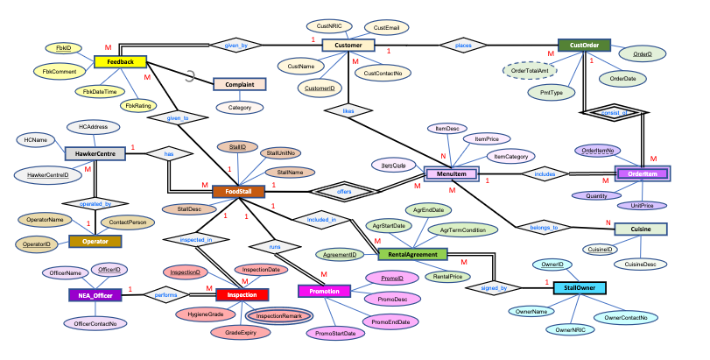

List of mapped Relations (Logical Design)
1. Complaint (<FbkID>, Category)
2. Cuisine (CuisineID, CuisineDesc)
3. Customer (CustomerID, CustNRIC, CustName, CustContactNo, CustEmail)
4. CustOrder (OrderID, OrderDate, PmtType, <CustomerID>)
5. Feedback (FbkID, FbkComment, FbkDateTime, FbkRating, <CustomerID>, <StallID>)
6. FoodStall (StallID, StallUnitNo, StallName, StallDesc, <HawkerCentreID>)
7. HawkerCentre (HawkerCentreID, HCName, HCAddress, <OperatorID>)
8. Inspection (InspectionID, InspectionDate, HygieneGrade, GradeExpiry, <OfficerID>,
<StallID>)
9. InspectionRemark (<InspectionID>, InspectionRemark)
10. Likes (<CustomerID>, <StallID, ItemCode>)
11. MenuItem (<StallID>, ItemCode, ItemDesc, ItemPrice, ItemCategory)
12. MenuItemCuisine (<CuisineID>, <StallID, ItemCode>)
13. NEA_Officer (OfficerID, OfficerName, OfficerContactNo)
14. Operator (OperatorID, OperatorName, ContactPerson)
15. OrderItem (<OrderID>, OrderItemNo, <StallID, ItemCode>, Quantity, UnitPrice)
16. Promotion (PromoID, PromoDesc, PromoStartDate, PromoEndDate, <StallID>)
17. RentalAgreement (AgreementID, AgrStartDate, AgrEndDate, AgrTermCondition, RentalPrice, <OwnerID>, <StallID>)
18. StallOwner (OwnerID, OwnerName, OwnerNRIC, OwnerContactNo)

Data Dictionary

HawkerCentre
Attribute Name | Description | Data Type and Length | Constraint | Null Value
HawkerCentreID | Unique identifier of each HawkerCentre | CHAR(5) | Primary Key | No
HCAddress | The physical address of the HawkerCentre | VARCHAR(200) |  | No
HCName | Name of HawkerCentre | VARCHAR(100) |  | No
OperatorID | Unique Identifier of Operator | CHAR(5) | FOREIGN KEY (OperatorID) REFERENCES Operator(OperatorID) | No

FoodStall
Attribute Name | Description | Data Type and Length | Constraint | Null Value
StallID | Unique identifier of each stall | CHAR(5) | Primary Key | No
StallName | Name of stall | VARCHAR(100) |  | No
StallDesc | Unique Identifier of Operator | VARCHAR(200) |  | Yes
StallUnitNo | Unit number in the Centre to identify the stall | VARCHAR(10) |  | No
HawkerCentreID | Unique identifier of the hawker center where the stall in located | CHAR(5) | FOREIGN KEY (HawkerCentreID) REFERENCES HawkerCentre(HawkerCentreID) | No

StallOwner
Attribute Name | Description | Data Type and Length | Constraint | Null Value
OwnerID | Unique identifier of each stall owner | CHAR(5) | Primary Key | No
OwnerName | Name of owner | VARCHAR(100) |  | No
OwnerNRIC | NRIC number of stall owner | CHAR(9) | Unique | No
OwnerContactNo | ContactNo of the stall owner | VARCHAR(15) |  | No

Complaint
Attribute Name | Description | Data Type and Length | Constraint | Null Value
FbkID | Unique identifier for each complaint | CHAR(5) | Primary Key  FOREIGN KEY (FbkID) REFERENCES Feedback(FbkID) | No
Category | Category of complaint | CHAR(10) |  | No

Customer
Attribute Name | Description | Data Type and Length | Constraint | Null Value
CustomerID | Unique identifier of each Customer | CHAR(5) | Primary Key | No
CustNRIC | NRIC of customer | VARCHAR(9) | Unique | No
CustName | Name of customer | VARCHAR(100) |  | No
CustContactNo | Contact number of customer | CHAR(10) |  | No
CustEmail | Email of customer | VARCHAR(50) | Unique | Yes

Feedback
Attribute Name | Description | Data Type and Length | Constraint | Null Value
FbkID | Unique identifier of each feedback | CHAR(5) | Primary Key | No
FbkComment | Customer’s comments about stall | VARCHAR(500) |  | Yes
FbkDateTime | Date and time when feedback was given (Default to Today’s date) | DATETIME |  | No
FbkRating | Rating given by customer (between 1-5) | TINYINT | Check (FbkRating >= 1 and FbkRating <= 5) | No
CustomerID | Unique identifier of customer | CHAR(5) | FOREIGN KEY (CustomerID) REFERENCES Customer(CustomerID) | No
StallID | Unique identifier of stall | CHAR(5) | FOREIGN KEY (StallID) REFERENCES FoodStall(StallID) | No

Likes
Attribute Name | Description | Data Type and Length | Constraint | Null Value
CustomerID | Identifies the customer | CHAR(5) | Primary Key  FOREIGN KEY (CustomerID) REFERENCES Customer(CustomerID) | No
StallID | Identifies the stall that sells the item the customer like | CHAR(5) | Primary Key  FOREIGN KEY (StallID, ItemCode) REFERENCES MenuItem(StallID, ItemCode) | NO
ItemCode | Identifies the item the customer likes | CHAR(5) | Primary Key  FOREIGN KEY (StallID, ItemCode) REFERENCES MenuItem(StallID, ItemCode) | No

CustOrder
Attribute Name | Description | Data Type and Length | Constraint | Null Value
OrderID | Unique ID for each order | CHAR(5) | Primary Key | No
OrderDate | Date the order was placed | DATETIME | CHECK (OrderDate <= GETDATE()) | No
PmtType | Payment Type (Card, cash, etc) | VARCHAR(30) |  | No
CustomerID | Unique ID of each customer | CHAR(5) | FOREIGN KEY (CustomerID) REFERENCES Customer(CustomerID) | No

OrderItem
Attribute Name | Description | Data Type and Length | Constraint | Null Value
OrderID | Unique ID for each order | CHAR(5) | Primary Key  FOREIGN KEY (OrderID) REFERENCES CustOrder(OrderID) | No
OrderItemNo | Position of item ordered | TINYINT | Primary Key | No
StallID | Unique ID of each stall | CHAR(5) | FOREIGN KEY (StallID, ItemCode) REFERENCES MenuItem(StallID, ItemCode) | No
ItemCode | Unique ID of each item | CHAR(5) | FOREIGN KEY (StallID, ItemCode) REFERENCES MenuItem(StallID, ItemCode) | No
Quantity | Number of this item ordered | TINYINT |  | No
UnitPrice | Price of single item | DECIMAL(10,2) | CHECK (UnitPrice > 0) | No

Operator
Attribute Name | Description | Data Type and Length | Constraint | Null Value
OperatorID | Unique Identifier of each operator | CHAR(5) | Primary Key | No
OperatorName | Name of operator | VARCHAR(255) |  | No
ContactPerson | Telephone Number of operator | CHAR(10) |  | No

NEA_Officer
Attribute Name | Description | Data Type and Length | Constraint | Null Value
OfficerID | Unique Identifier of each employee | CHAR(5) | Primary Key | No
OfficerName | Name of  Officer | VARCHAR(50) |  | No
OfficerContactNo | Telephone Number of Officer | CHAR(10) |  | No

Inspection
Attribute Name | Description |  | Data Type and Length | Constraint | Null Value
InspectionID |  | Unique Identifier of each Inspection | CHAR(5) | Primary Key |  | No
InspectionDate |  | Date of Inspection | DATETIME | CHECK (InspectionDate <= GETDATE()) |  | No
HygieneGrade |  | Hygiene Grade given to stall | CHAR(1) | CHECK (HygieneGrade IN ('A','B','C')) |  | No
GradeExpiry |  | Expiry date of Grade | DATETIME |  |  | No
OfficerID |  | Unique identifier of each Officer | CHAR(5) | FOREIGN KEY (OfficerID) REFERENCES NEA_Officer(OfficerID) |  | No
StallID |  | Unique identifier of each stall | CHAR(5) | FOREIGN KEY (StallID) REFERENCES FoodStall(StallID) |  | No

InspectionRemark
Attribute Name | Description | Data Type and Length | Constraint | Null Value
InspectionID | Unique Identifier of each Inspection | CHAR(5) | Primary Key  FOREIGN KEY (InspectionID) REFERENCES Inspection(InspectionID) | No
InspectionRemark | Comments regarding the inspection | VARCHAR(700) | Primary Key | No

RentalAgreement
Attribute Name | Description | Data Type and Length | Constraint | Null Value
AgreementID | Unique identifier for the rental agreement | CHAR(5) | Primary Key | No
AgrStartDate | The date the rental period begins | DATETIME |  | No
AgrEndDate | The date the rental period expires | DATETIME |  | No
AgrTermCondition | Specific terms and conditions of the lease | VARCHAR(8000) |  | Yes
RentalPrice | Monthly rental fee for the stall unit | DECIMAL(10,2) |  | No
OwnerID | Identifier for the stall owner | CHAR(5) | FOREIGN KEY (OwnerID) REFERENCES StallOwner(OwnerID) | No
StallID | Identifier for the physical stall unit | CHAR(5) | FOREIGN KEY (StallID) REFERENCES FoodStall(StallID) | No

Promotion
Attribute Name | Description | Data Type and Length | Constraint | Null Value
PromoID | Unique identifier for the promotion | CHAR(5) | Primary Key | No
PromoDesc | Detailed description of the offer | VARCHAR(255) |  | No
PromoStartDate | Date the promotion becomes active | DATETIME |  | No
PromoEndDate | Date the promotion concludes | DATETIME |  | No
StallID | Identifier for the stall offering the promo | CHAR(5) | FOREIGN KEY (StallID) REFERENCES FoodStall(StallID) | No

MenuItem
Attribute Name | Description | Data Type and Length | Constraint | Null Value
StallID | Identifier for the stall owning the item | CHAR(5) | Primary Key  FOREIGN KEY (StallID) REFERENCES FoodStall(StallID) | No
ItemCode | Stall-specific code for the menu item | CHAR(5) | Primary Key | No
ItemDesc | Name and brief description of the dish | VARCHAR(100) |  | No
ItemPrice | Standard selling price per unit | DECIMAL(10,2) | CHECK (ItemPrice>0) | No
ItemCategory | Classification (e.g., Main, Drink, Side) | VARCHAR(50) |  | Yes

Cuisine
Attribute Name | Description | Data Type and Length | Constraint | Null Value
CuisineID | Unique identifier for the cuisine type | CHAR(5) | Primary Key | No
CuisineDesc | Name or description of the cuisine | VARCHAR(50) |  | No

MenuItemCuisine
Attribute Name | Description | Data Type and Length | Constraint | Null Value
CuisineID | Identifier for the cuisine | CHAR(5) | Primary Key  FOREIGN KEY (CuisineID) REFERENCES Cuisine(CuisineID) | No
StallID | ID of the stall owning the item | CHAR(5) | Primary Key  FOREIGN KEY (StallID, ItemCode) REFERENCES MenuItem(StallID, ItemCode) | No
ItemCode | Stall-specific code for the item | CHAR(5) | Primary Key  FOREIGN KEY (StallID, ItemCode) REFERENCES MenuItem(StallID, ItemCode) | No

SQL Database Setup Script
-- SETUP
DROP DATABASE IF EXISTS HawkerManagementDB;
CREATE DATABASE HawkerManagementDB;
GO

USE HawkerManagementDB;
DROP TABLE IF EXISTS Promotion;
DROP TABLE IF EXISTS RentalAgreement;
DROP TABLE IF EXISTS MenuItemCuisine;
DROP TABLE IF EXISTS Likes;
DROP TABLE IF EXISTS Complaint;
DROP TABLE IF EXISTS Feedback;
DROP TABLE IF EXISTS InspectionRemark;
DROP TABLE IF EXISTS Inspection;
DROP TABLE IF EXISTS OrderItem;
DROP TABLE IF EXISTS CustOrder;
DROP TABLE IF EXISTS MenuItem;
DROP TABLE IF EXISTS FoodStall;
DROP TABLE IF EXISTS HawkerCentre;
DROP TABLE IF EXISTS NEA_Officer;
DROP TABLE IF EXISTS Cuisine;
DROP TABLE IF EXISTS StallOwner;
DROP TABLE IF EXISTS Customer;
DROP TABLE IF EXISTS Operator;

CREATE TABLE Operator (
OperatorID CHAR(5) NOT NULL, -- OP***
OperatorName VARCHAR(255) NOT NULL,
ContactPerson CHAR(10) NOT NULL,
CONSTRAINT PK_Operator PRIMARY KEY (OperatorID)
)

CREATE TABLE Customer (
CustomerID CHAR(5) NOT NULL, -- CS***
CustNRIC VARCHAR(9) NOT NULL UNIQUE,
CustName VARCHAR(100) NOT NULL,
CustContactNo CHAR(10) NOT NULL UNIQUE,
CustEmail VARCHAR(50) NULL UNIQUE,
CONSTRAINT PK_CustomerID PRIMARY KEY (CustomerID)
);

CREATE TABLE StallOwner (
OwnerID CHAR(5) NOT NULL, -- OW***
OwnerName VARCHAR(100) NOT NULL,
OwnerNRIC CHAR(9) NOT NULL UNIQUE,
OwnerContactNo VARCHAR(15) NOT NULL,
CONSTRAINT PK_OwnerIdentifier PRIMARY KEY (OwnerID)
);

CREATE TABLE Cuisine (
CuisineID CHAR(5) NOT NULL, --CU***
CuisineDesc VARCHAR(50) NOT NULL,
CONSTRAINT PK_Cuisine PRIMARY KEY (CuisineID)
);

CREATE TABLE NEA_Officer (
OfficerID CHAR(5) NOT NULL, --OC***
OfficerName VARCHAR(255) NOT NULL,
OfficerContactNo CHAR(10) NOT NULL,
CONSTRAINT PK_Officer PRIMARY KEY (OfficerID),
)

CREATE TABLE HawkerCentre (
HawkerCentreID CHAR(5) NOT NULL, --HC***
HCName VARCHAR(100) NOT NULL,
HCAddress VARCHAR(200) NOT NULL,
OperatorID CHAR(5) NOT NULL,
CONSTRAINT PK_HCentreID PRIMARY KEY (HawkerCentreID),
CONSTRAINT FK_Operator_HCentre FOREIGN KEY (OperatorID) REFERENCES Operator(OperatorID)
);

CREATE TABLE FoodStall (
StallID CHAR(5) NOT NULL, --ST***
StallUnitNo VARCHAR(10) NOT NULL,
StallName VARCHAR(100) NOT NULL,
StallDesc VARCHAR(200),
HawkerCentreID CHAR(5) NOT NULL,
CONSTRAINT PK_StallIdentifier PRIMARY KEY (StallID),
CONSTRAINT FK_FoodStall_HCentre FOREIGN KEY (HawkerCentreID) REFERENCES HawkerCentre(HawkerCentreID)
);

CREATE TABLE MenuItem (
StallID CHAR(5) NOT NULL,
ItemCode CHAR(5) NOT NULL, --IC***
ItemDesc VARCHAR(100) NOT NULL,
ItemPrice DECIMAL(10,2) NOT NULL CHECK (ItemPrice>0),
ItemCategory VARCHAR(50) NULL,
CONSTRAINT PK_MenuItem PRIMARY KEY (StallID, ItemCode),
CONSTRAINT FK_MenuItem_Stall FOREIGN KEY (StallID) REFERENCES FoodStall(StallID)
);

CREATE TABLE CustOrder (
OrderID CHAR(5) NOT NULL, --OD***
OrderDate DATETIME NOT NULL,
PmtType VARCHAR(30) NOT NULL,
CustomerID CHAR(5) NOT NULL,
CONSTRAINT PK_CustOrder PRIMARY KEY (OrderID),
CONSTRAINT FK_CustOrder_Customer FOREIGN KEY (CustomerID) REFERENCES Customer(CustomerID),
CONSTRAINT CK_CustOrder CHECK (OrderDate <= GETDATE())
);

CREATE TABLE OrderItem (
OrderID CHAR(5) NOT NULL,
OrderItemNo TINYINT NOT NULL,
StallID CHAR(5) NOT NULL,
ItemCode CHAR(5) NOT NULL,
Quantity TINYINT NOT NULL,
UnitPrice DECIMAL(10,2) NOT NULL CHECK (UnitPrice > 0),
CONSTRAINT PK_OrderItem PRIMARY KEY (OrderID, OrderItemNo),
CONSTRAINT FK_OrderItem_Order FOREIGN KEY (OrderID) REFERENCES CustOrder(OrderID),
CONSTRAINT FK_OrderItem_MenuItem FOREIGN KEY (StallID, ItemCode) REFERENCES MenuItem(StallID, ItemCode)
);

CREATE TABLE Inspection (
InspectionID CHAR(5) NOT NULL, --IN***
InspectionDate DATETIME NOT NULL,
HygieneGrade CHAR(1) NOT NULL,
GradeExpiry DATETIME NOT NULL,
OfficerID CHAR(5) NOT NULL,
StallID CHAR(5) NOT NULL,
CONSTRAINT PK_Inspection PRIMARY KEY (InspectionID),
CONSTRAINT FK_Inspection_Officer FOREIGN KEY (OfficerID) REFERENCES NEA_Officer(OfficerID),
CONSTRAINT FK_Inspection_Stall FOREIGN KEY (StallID) REFERENCES FoodStall(StallID),
CONSTRAINT InspectionDate CHECK (InspectionDate <= GETDATE()),
CONSTRAINT HygieneGrade CHECK (HygieneGrade IN ('A','B','C'))
)

CREATE TABLE InspectionRemark (
InspectionID CHAR(5) NOT NULL,
InspectionRemark VARCHAR(700) NOT NULL,
CONSTRAINT PK_InspectionRemark PRIMARY KEY (InspectionID, InspectionRemark),
CONSTRAINT FK_InspectionRemark_Inspection FOREIGN KEY (InspectionID) REFERENCES Inspection(InspectionID)
)

CREATE TABLE Feedback (
FbkID CHAR(5) NOT NULL, --FB***
FbkComment VARCHAR(500),
FbkDateTime DATETIME NOT NULL,
FbkRating TINYINT NOT NULL CHECK (FbkRating IN (1,2,3,4,5)),
CustomerID CHAR(5) NOT NULL,
StallID CHAR(5) NOT NULL,
CONSTRAINT PK_FbkID PRIMARY KEY (FbkID),
CONSTRAINT FK_Feedback_CustomerID FOREIGN KEY (CustomerID) REFERENCES Customer(CustomerID),
CONSTRAINT FK_Feedback_StallID FOREIGN KEY (StallID) REFERENCES FoodStall(StallID)
);

CREATE TABLE Complaint (
FbkID CHAR(5) NOT NULL,
Category CHAR(10) NOT NULL,
CONSTRAINT PK_ComplaintID PRIMARY KEY (FbkID),
CONSTRAINT FK_FbkID FOREIGN KEY (FbkID) REFERENCES Feedback(FbkID),
);

CREATE TABLE Likes (
CustomerID CHAR(5) NOT NULL,
StallID CHAR(5) NOT NULL,
ItemCode CHAR(5) NOT NULL,
CONSTRAINT PK_Likes PRIMARY KEY (CustomerID, StallID, ItemCode),
CONSTRAINT FK_Likes_CustomerID FOREIGN KEY (CustomerID) REFERENCES Customer(CustomerID),
CONSTRAINT FK_Likes_StallIDItemCode FOREIGN KEY (StallID, ItemCode) REFERENCES MenuItem(StallID, ItemCode)
);

CREATE TABLE MenuItemCuisine (
CuisineID CHAR(5) NOT NULL,
StallID CHAR(5) NOT NULL,
ItemCode CHAR(5) NOT NULL,
CONSTRAINT PK_MenuItemCuisine PRIMARY KEY (CuisineID, StallID, ItemCode),
CONSTRAINT FK_MIC_Cuisine FOREIGN KEY (CuisineID) REFERENCES Cuisine(CuisineID),
CONSTRAINT FK_MIC_MenuItem FOREIGN KEY (StallID, ItemCode) REFERENCES MenuItem(StallID, ItemCode)
);

CREATE TABLE RentalAgreement (
AgreementID CHAR(5) NOT NULL, --AG***
AgrStartDate DATETIME NOT NULL,
AgrEndDate DATETIME NOT NULL,
AgrTermCondition VARCHAR(8000) NULL,
RentalPrice DECIMAL(10,2) NOT NULL,
OwnerID CHAR(5) NOT NULL,
StallID CHAR(5) NOT NULL,
CONSTRAINT PK_RentalAgreement PRIMARY KEY (AgreementID),
CONSTRAINT FK_Rental_Owner FOREIGN KEY (OwnerID) REFERENCES StallOwner(OwnerID),
CONSTRAINT FK_Rental_Stall FOREIGN KEY (StallID) REFERENCES FoodStall(StallID)
);

CREATE TABLE Promotion (
PromoID CHAR(5) NOT NULL, --PR***
PromoDesc VARCHAR(255) NOT NULL,
PromoStartDate DATETIME NOT NULL,
PromoEndDate DATETIME NOT NULL,
StallID CHAR(5) NOT NULL,
CONSTRAINT PK_Promotion PRIMARY KEY (PromoID),
CONSTRAINT FK_Promotion_Stall FOREIGN KEY (StallID) REFERENCES FoodStall(StallID)
);

/*
All formats of IDs are as follows: (First 2 characters: Type of ID)(Last 3 characters: Serial number)
OperatorID: OP***
CustomerID: CS***
OfficerID: OC***
OwnerID: OW***
CuisineID: CU***
HawkerCentreID: HC***
StallID: ST***
ItemCode: IC***
OrderID: OD***
InspectionID: IN***
FbkID: FB***
AgreementID: AG***
PromoID: PR***
*/

-- 1. Operator
INSERT INTO Operator (OperatorID, OperatorName, ContactPerson) VALUES
('OP001', 'Kopitiam Management', '91234567'),
('OP002', 'Food Republic', '92345678'),
('OP003', 'NTUC Foodfare', '93456789'),
('OP004', 'Koufu Pte Ltd', '94567890'),
('OP005', 'S11 Food House', '95678901'),
('OP006', 'Broadway Coffeeshop', '96789012'),
('OP007', 'Kimly Group', '97890123'),
('OP008', 'Chang Cheng Group', '98901234'),
('OP009', 'Fei Siong Group', '99012345'),
('OP010', 'Select Group', '90123456');

-- 2. HawkerCentre
INSERT INTO HawkerCentre (HawkerCentreID, HCName, HCAddress, OperatorID) VALUES
('HC001', 'Lau Pa Sat', '18 Raffles Quay', 'OP001'),
('HC002', 'Newton Food Centre', '500 Clemenceau Ave', 'OP001'),
('HC003', 'Maxwell Food Centre', '1 Kadayanallur St', 'OP002'),
('HC004', 'Amoy Street Food Centre', '7 Maxwell Rd', 'OP002'),
('HC005', 'Tiong Bahru Market', '30 Seng Poh Rd', 'OP003'),
('HC006', 'Chomp Chomp', '20 Kensington Park Rd', 'OP004'),
('HC007', 'Old Airport Road', '51 Old Airport Rd', 'OP005'),
('HC008', 'Tekka Centre', '665 Buffalo Rd', 'OP006'),
('HC009', 'Hong Lim Complex', '531A Upper Cross St', 'OP007'),
('HC010', 'Golden Mile', '505 Beach Rd', 'OP008');

-- 3. StallOwner
INSERT INTO StallOwner (OwnerID, OwnerName, OwnerNRIC, OwnerContactNo) VALUES
('OW001', 'Tan Ah Kow', 'S1234567A', '91112222'),
('OW002', 'Lim Mee Pok', 'S2234567B', '92223333'),
('OW003', 'Siti Binte Rahim', 'S3234567C', '93334444'),
('OW004', 'Muthu Kumar', 'S4234567D', '94445555'),
('OW005', 'John Doe', 'S5234567E', '95556666'),
('OW006', 'Mary Jane', 'S6234567F', '96667777'),
('OW007', 'Peter Parker', 'S7234567G', '97778888'),
('OW008', 'Bruce Wayne', 'S8234567H', '98889999'),
('OW009', 'Clark Kent', 'S9234567I', '99990000'),
('OW010', 'Diana Prince', 'S0234567J', '90001111');

-- 4. Customer
INSERT INTO Customer (CustomerID, CustNRIC, CustName, CustContactNo, CustEmail) VALUES
('CS001', 'S8000001A', 'Alice Tan', '81110001', 'alice@email.com'),
('CS002', 'S8000002B', 'Bob Lim', '81110002', 'bob@email.com'),
('CS003', 'S8000003C', 'Charlie Chan', '81110003', 'charlie@email.com'),
('CS004', 'S8000004D', 'David Teo', '81110004', 'david@email.com'),
('CS005', 'S8000005E', 'Eve Ng', '81110005', 'eve@email.com'),
('CS006', 'S8000006F', 'Franky Lee', '81110006', 'frank@email.com'),
('CS007', 'S8000007G', 'Grace Ho', '81110007', 'grace@email.com'),
('CS008', 'S8000008H', 'Harry Potter', '81110008', 'harry@email.com'),
('CS009', 'S8000009I', 'Ivy Chee', '81110009', 'ivy@email.com'),
('CS010', 'S8000010J', 'Jack Neo', '81110010', 'jack@email.com');

-- 5. NEA_Officer
INSERT INTO NEA_Officer (OfficerID, OfficerName, OfficerContactNo) VALUES
('OC001', 'Officer James', '61234567'),
('OC002', 'Officer Sarah', '62345678'),
('OC003', 'Officer Mike', '63456789'),
('OC004', 'Officer Linda', '64567890'),
('OC005', 'Officer Robert', '65678901'),
('OC006', 'Officer Patricia', '66789012'),
('OC007', 'Officer William', '67890123'),
('OC008', 'Officer Elizabeth', '68901234'),
('OC009', 'Officer David', '69012345'),
('OC010', 'Officer Jennifer', '60123456');

-- 6. Cuisine
INSERT INTO Cuisine (CuisineID, CuisineDesc) VALUES
('CU001', 'Chicken Rice'),
('CU002', 'Western'),
('CU003', 'Indian'),
('CU004', 'Malay'),
('CU005', 'Noodles'),
('CU006', 'Drinks'),
('CU007', 'Japanese'),
('CU008', 'Korean'),
('CU009', 'Dessert'),
('CU010', 'Vegetarian');

-- 7. FoodStall (Depends on HawkerCentre)
INSERT INTO FoodStall (StallID, StallUnitNo, StallName, StallDesc, HawkerCentreID) VALUES
('ST001', '01-01', 'Tian Tian Chicken Rice', 'Famous chicken rice', 'HC003'),
('ST002', '01-02', 'Ah Bole Mee Pok', 'Teochew noodles', 'HC003'),
('ST003', '01-15', 'Newton BBQ Wings', 'Best wings in town', 'HC002'),
('ST004', '02-30', 'Lau Pa Sat Satay', 'Satay street', 'HC001'),
('ST005', '01-10', 'Heng Carrot Cake', 'Black and white', 'HC002'),
('ST006', '01-50', 'Amoy Nasi Lemak', 'Fragrant rice', 'HC004'),
('ST007', '01-22', 'Tiong Bahru Pau', 'Steamed buns', 'HC005'),
('ST008', '01-05', 'Bedok Chwee Kueh', 'Rice cakes', 'HC005'),
('ST009', '01-99', 'Old Airport Lor Mee', 'Braised noodles', 'HC007'),
('ST010', '01-33', 'Tekka Biryani', 'Mutton biryani', 'HC008');

-- 8. CustOrder (Depends on Customer)
INSERT INTO CustOrder (OrderID, OrderDate, PmtType, CustomerID) VALUES
('OD001', '2025-10-01 12:00', 'Cash', 'CS001'),
('OD002', '2025-10-01 12:05', 'PayLah', 'CS002'),
('OD003', '2025-10-02 13:00', 'GrabPay', 'CS003'),
('OD004', '2025-10-02 18:00', 'Cash', 'CS004'),
('OD005', '2025-10-03 12:30', 'Credit Card', 'CS005'),
('OD006', '2025-10-03 19:00', 'Cash', 'CS006'),
('OD007', '2025-10-04 12:15', 'PayNow', 'CS007'),
('OD008', '2025-10-04 12:45', 'Cash', 'CS008'),
('OD009', '2025-10-05 13:30', 'Nets', 'CS009'),
('OD010', '2025-10-05 14:00', 'Cash', 'CS010'),
('OD011', '2025-10-06 12:30', 'PayNow', 'CS001'),
('OD012', '2025-10-10 18:45', 'Cash', 'CS001'),
('OD013', '2025-10-15 13:00', 'PayLah', 'CS001'),
('OD014', '2025-10-08 12:15', 'GrabPay', 'CS002'),
('OD015', '2025-10-12 19:30', 'Cash', 'CS002'),
('OD016', '2025-10-07 11:45', 'Cash', 'CS003'),
('OD017', '2025-10-11 12:30', 'PayNow', 'CS003'),
('OD018', '2025-10-14 18:00', 'Nets', 'CS003'),
('OD019', '2025-10-09 13:15', 'Credit Card', 'CS004'),
('OD020', '2025-10-13 12:00', 'Cash', 'CS004'),
('OD021', '2025-10-10 12:45', 'PayLah', 'CS005'),
('OD022', '2025-10-16 19:00', 'GrabPay', 'CS005'),
('OD023', '2025-10-11 11:30', 'Cash', 'CS006'),
('OD024', '2025-10-17 18:30', 'PayNow', 'CS006'),
('OD025', '2025-10-12 12:00', 'Nets', 'CS007'),
('OD026', '2025-10-18 13:30', 'Cash', 'CS007'),
('OD027', '2025-10-13 18:45', 'PayLah', 'CS008'),
('OD028', '2025-10-19 19:15', 'Cash', 'CS008'),
('OD029', '2025-10-14 14:00', 'GrabPay', 'CS009'),
('OD030', '2025-10-20 12:30', 'Credit Card', 'CS010');

-- 9. MenuItem (Depends on FoodStall)
INSERT INTO MenuItem (StallID, ItemCode, ItemDesc, ItemPrice, ItemCategory) VALUES
('ST001', 'IC001', 'Steamed Chicken Rice', 5.50, 'Main'),
('ST001', 'IC002', 'Roasted Chicken Rice', 5.50, 'Main'),
('ST002', 'IC001', 'Fishball Noodles', 4.50, 'Main'),
('ST002', 'IC002', 'Minced Meat Noodles', 5.00, 'Main'),
('ST003', 'IC001', 'BBQ Chicken Wing', 1.50, 'Side'),
('ST004', 'IC001', 'Chicken Satay (10 sticks)', 8.00, 'Side'),
('ST005', 'IC001', 'Fried Carrot Cake', 4.00, 'Main'),
('ST006', 'IC001', 'Nasi Lemak Set A', 4.50, 'Main'),
('ST007', 'IC001', 'Big Pau', 1.80, 'Side'),
('ST010', 'IC001', 'Chicken Biryani', 7.50, 'Main'),
('ST001', 'IC003', 'Vegetarian Chicken Rice', 5.00, 'Main'),
('ST002', 'IC003', 'Vegetarian Noodles', 4.50, 'Main'),
('ST005', 'IC002', 'Vegetarian Fried Carrot Cake', 4.00, 'Main'),
('ST006', 'IC002', 'Vegetarian Nasi Lemak', 4.50, 'Main'),
('ST008', 'IC001', 'Vegetarian Breakfast Set', 3.80, 'Main'),
('ST009', 'IC001', 'Vegetarian Omelette Rice', 4.20, 'Main');

-- 10. RentalAgreement (Depends on Owner, FoodStall)
INSERT INTO RentalAgreement (AgreementID, AgrStartDate, AgrEndDate, RentalPrice, OwnerID, StallID) VALUES
('AG001', '2025-01-01', '2027-01-01', 3000.00, 'OW001', 'ST001'),
('AG002', '2025-01-01', '2027-01-01', 2800.00, 'OW002', 'ST002'),
('AG003', '2025-02-01', '2027-02-01', 3200.00, 'OW003', 'ST003'),
('AG004', '2025-03-01', '2027-03-01', 3500.00, 'OW004', 'ST004'),
('AG005', '2025-01-01', '2027-01-01', 2500.00, 'OW005', 'ST005'),
('AG006', '2025-04-01', '2027-04-01', 2900.00, 'OW006', 'ST006'),
('AG007', '2025-05-01', '2027-05-01', 3100.00, 'OW007', 'ST007'),
('AG008', '2025-06-01', '2027-06-01', 2700.00, 'OW008', 'ST008'),
('AG009', '2025-01-01', '2027-01-01', 3000.00, 'OW009', 'ST009'),
('AG010', '2025-07-01', '2027-07-01', 3300.00, 'OW010', 'ST010');

-- 11. Inspection (Depends on Officer, FoodStall)
INSERT INTO Inspection (InspectionID, InspectionDate, HygieneGrade, GradeExpiry, OfficerID, StallID) VALUES
('IN001', '2025-09-01', 'A', '2026-09-01', 'OC001', 'ST001'),
('IN002', '2025-09-02', 'B', '2026-01-01', 'OC002', 'ST002'),
('IN003', '2025-09-03', 'A', '2026-09-03', 'OC003', 'ST003'),
('IN004', '2025-09-04', 'B', '2026-09-04', 'OC001', 'ST004'),
('IN005', '2025-09-05', 'A', '2026-09-05', 'OC004', 'ST005'),
('IN006', '2025-09-06', 'C', '2026-09-06', 'OC005', 'ST006'),
('IN007', '2025-09-07', 'A', '2026-09-07', 'OC006', 'ST007'),
('IN008', '2025-09-08', 'B', '2026-09-08', 'OC007', 'ST008'),
('IN009', '2025-09-09', 'A', '2026-09-09', 'OC008', 'ST009'),
('IN010', '2025-09-10', 'A', '2026-09-10', 'OC009', 'ST010'),
('IN011', '2023-03-10', 'C', '2024-03-10', 'OC001', 'ST001'),
('IN012', '2023-03-12', 'C', '2024-03-12', 'OC002', 'ST002'),
('IN013', '2023-03-14', 'C', '2024-03-14', 'OC003', 'ST003'),
('IN014', '2023-03-16', 'B', '2024-03-16', 'OC004', 'ST004'),
('IN015', '2023-03-18', 'C', '2024-03-18', 'OC005', 'ST005'),
('IN016', '2024-02-05', 'B', '2025-02-05', 'OC001', 'ST001'),
('IN017', '2024-02-07', 'C', '2025-02-07', 'OC002', 'ST002'),
('IN018', '2024-02-09', 'B', '2025-02-09', 'OC003', 'ST003'),
('IN019', '2024-02-11', 'B', '2025-02-11', 'OC004', 'ST004'),
('IN020', '2024-02-13', 'C', '2025-02-13', 'OC005', 'ST006'),
('IN021', '2025-01-03', 'B', '2026-01-03', 'OC006', 'ST002'),
('IN022', '2025-01-06', 'A', '2026-01-06', 'OC007', 'ST003'),
('IN023', '2025-01-09', 'C', '2026-01-09', 'OC008', 'ST006'),
('IN024', '2025-01-12', 'B', '2026-01-12', 'OC009', 'ST008');

-- 12. FeedBack (Depends on Customer, FoodStall)
INSERT INTO Feedback (FbkID, FbkComment, FbkDateTime, FbkRating, CustomerID, StallID) VALUES
('FB001', 'Great food!', '2025-10-01 13:00', 5, 'CS001', 'ST001'),
('FB002', 'Too salty', '2025-10-02 14:00', 2, 'CS002', 'ST002'),
('FB003', 'Excellent service', '2025-10-03 15:00', 5, 'CS003', 'ST003'),
('FB004', 'Long queue', '2025-10-04 16:00', 3, 'CS004', 'ST004'),
('FB005', 'Tastes okay', '2025-10-05 17:00', 4, 'CS005', 'ST005'),
('FB006', 'Dirty tables', '2025-10-06 18:00', 1, 'CS006', 'ST006'),
('FB007', 'Love the pau', '2025-10-07 19:00', 5, 'CS007', 'ST007'),
('FB008', 'Cheap and good', '2025-10-08 20:00', 4, 'CS008', 'ST008'),
('FB009', 'Portion small', '2025-10-09 21:00', 2, 'CS009', 'ST009'),
('FB010', 'Best Biryani', '2025-10-10 22:00', 5, 'CS010', 'ST010'),
('FB011', 'Service was significantly slower today', '2025-10-11 12:30', 3, 'CS003', 'ST003'),
('FB012', 'Tried the new menu item, very spicy!', '2025-10-14 13:00', 4, 'CS003', 'ST004'),
('FB013', 'Brought my family, everyone loved it', '2025-10-16 19:00', 5, 'CS003', 'ST001'),
('FB014', 'Coffee was a bit diluted this morning', '2025-10-18 08:30', 2, 'CS003', 'ST006'),
('FB015', 'Came back for the chicken rice, consistent quality', '2025-10-11 12:45', 5, 'CS001', 'ST001'),
('FB016', 'Noodles were a bit oily for my liking', '2025-10-13 13:15', 3, 'CS001', 'ST002'),
('FB017', 'Quick lunch, fast service as always', '2025-10-19 12:15', 4, 'CS001', 'ST001'),
('FB018', 'My favorite dessert spot now', '2025-10-12 19:30', 5, 'CS007', 'ST005'),
('FB019', 'Bought for my colleagues, they asked for more', '2025-10-15 14:00', 5, 'CS007', 'ST007'),
('FB020', 'Soup was cold, disappointing', '2025-10-12 12:00', 2, 'CS004', 'ST009'),
('FB021', 'Queue is still too long!', '2025-10-20 18:45', 3, 'CS004', 'ST004'),
('FB022', 'Portion seems to have improved', '2025-10-15 20:15', 4, 'CS008', 'ST008'),
('FB023', 'Not as good as last time', '2025-10-21 20:30', 3, 'CS008', 'ST008'),
('FB024', 'Better seasoning this time', '2025-10-14 14:30', 4, 'CS002', 'ST002'),
('FB025', 'Biryani rice was perfectly cooked again', '2025-10-22 12:00', 5, 'CS010', 'ST010');

-- 13. OrderItem (Depends on CustOrder, MenuItem)
INSERT INTO OrderItem (OrderID, OrderItemNo, StallID, ItemCode, Quantity, UnitPrice) VALUES
('OD001', 1, 'ST001', 'IC001', 1, 5.50),
('OD001', 2, 'ST001', 'IC002', 1, 5.50),
('OD002', 1, 'ST002', 'IC001', 2, 4.50),
('OD003', 1, 'ST003', 'IC001', 5, 1.50),
('OD004', 1, 'ST004', 'IC001', 1, 8.00),
('OD005', 1, 'ST005', 'IC001', 1, 4.00),
('OD006', 1, 'ST006', 'IC001', 1, 4.50),
('OD007', 1, 'ST007', 'IC001', 3, 1.80),
('OD008', 1, 'ST001', 'IC001', 1, 5.50),
('OD009', 1, 'ST010', 'IC001', 2, 7.50),
('OD010', 1, 'ST002', 'IC002', 1, 5.00),
('OD011', 1, 'ST001', 'IC001', 2, 5.50),
('OD011', 2, 'ST001', 'IC002', 1, 5.50),
('OD012', 1, 'ST003', 'IC001', 10, 1.50),
('OD013', 1, 'ST004', 'IC001', 2, 8.00),
('OD014', 1, 'ST002', 'IC001', 1, 4.50),
('OD014', 2, 'ST002', 'IC002', 1, 5.00),
('OD015', 1, 'ST006', 'IC001', 2, 4.50),
('OD016', 1, 'ST003', 'IC001', 8, 1.50),
('OD017', 1, 'ST001', 'IC001', 1, 5.50),
('OD018', 1, 'ST007', 'IC001', 5, 1.80),
('OD019', 1, 'ST004', 'IC001', 3, 8.00),
('OD020', 1, 'ST010', 'IC001', 1, 7.50),
('OD021', 1, 'ST005', 'IC001', 2, 4.00),
('OD022', 1, 'ST002', 'IC001', 1, 4.50),
('OD022', 2, 'ST002', 'IC002', 1, 5.00),
('OD023', 1, 'ST001', 'IC001', 1, 5.50),
('OD023', 2, 'ST001', 'IC002', 1, 5.50),
('OD024', 1, 'ST006', 'IC001', 3, 4.50),
('OD025', 1, 'ST007', 'IC001', 4, 1.80),
('OD026', 1, 'ST003', 'IC001', 6, 1.50),
('OD027', 1, 'ST001', 'IC001', 2, 5.50),
('OD028', 1, 'ST004', 'IC001', 2, 8.00),
('OD029', 1, 'ST005', 'IC001', 1, 4.00),
('OD030', 1, 'ST010', 'IC001', 4, 7.50);

-- 14. MenuItemCuisine (Link Items to Cuisine)
INSERT INTO MenuItemCuisine (CuisineID, StallID, ItemCode) VALUES
('CU001', 'ST001', 'IC001'),
('CU001', 'ST001', 'IC002'),
('CU005', 'ST002', 'IC001'),
('CU005', 'ST002', 'IC002'),
('CU002', 'ST003', 'IC001'),
('CU004', 'ST004', 'IC001'),
('CU005', 'ST005', 'IC001'),
('CU004', 'ST006', 'IC001'),
('CU009', 'ST007', 'IC001'),
('CU010', 'ST001', 'IC003'),
('CU010', 'ST002', 'IC003'),
('CU010', 'ST005', 'IC002'),
('CU010', 'ST006', 'IC002'),
('CU010', 'ST008', 'IC001'),
('CU010', 'ST009', 'IC001'),
('CU003', 'ST010', 'IC001');

-- 15. InspectionRemark (Depends on Inspection)
INSERT INTO InspectionRemark (InspectionID, InspectionRemark) VALUES
('IN001', 'Excellent hygiene standards.'),
('IN002', 'Floor was slightly slippery.'),
('IN003', 'Good food handling practices.'),
('IN004', 'Freezer temp slightly high.'),
('IN005', 'Very clean.'),
('IN006', 'Pest found near drainage.'),
('IN007', 'Staff attire is neat.'),
('IN008', 'Trash bin full.'),
('IN009', 'Spotless kitchen.'),
('IN010', 'Spices stored correctly.');

-- 16. Complaint (Depends on Feedback)
INSERT INTO Complaint (FbkID, Category) VALUES
('FB002', 'FoodQual'),
('FB006', 'Hygiene'),
('FB009', 'Quantity');

-- 17. Likes (Depends on Customer, MenuItem)
INSERT INTO Likes (CustomerID, StallID, ItemCode) VALUES
('CS001', 'ST001', 'IC001'),
('CS002', 'ST002', 'IC001'),
('CS003', 'ST003', 'IC001'),
('CS001', 'ST004', 'IC001'),
('CS005', 'ST001', 'IC001'),
('CS006', 'ST006', 'IC001'),
('CS007', 'ST007', 'IC001'),
('CS010', 'ST010', 'IC001'),
('CS001', 'ST010', 'IC001'),
('CS002', 'ST005', 'IC001');

-- 18. Promotion
INSERT INTO Promotion (PromoID, PromoDesc, PromoStartDate, PromoEndDate, StallID) VALUES
('PR001', '10% Off Lunch', '2026-01-20', '2026-02-02', 'ST001'),
('PR002', 'Free Drink with Set', '2026-01-15', '2026-02-01', 'ST002'),
('PR003', 'Buy 5 Get 1 Free', '2026-01-25', '2026-02-03', 'ST003'),
('PR004', 'Satay Platter Promo', '2026-02-04', '2026-02-10', 'ST004'),
('PR005', '$1 Off Min Spend $5', '2026-02-05', '2026-02-12', 'ST005'),
('PR006', 'Student Meal', '2026-02-03', '2026-02-07', 'ST006'),
('PR007', '3 Paus for $5', '2026-01-28', '2026-02-10', 'ST007'),
('PR008', 'Breakfast Special', '2026-01-01', '2026-02-28', 'ST008'),
('PR009', 'Add Egg Free', '2026-01-05', '2026-01-15', 'ST009'),
('PR010', 'Family Set Deal', '2026-02-10', '2026-02-20', 'ST010');

GO

Content Listing of All Tables

Operator Table:
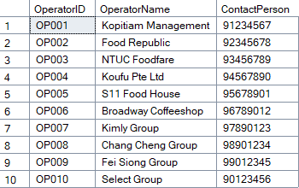

HawkerCentre Table:
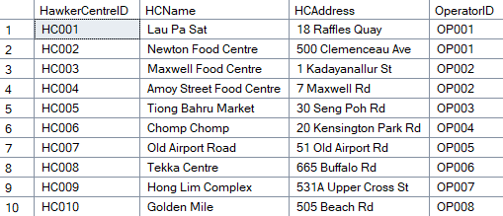

StallOwner Table:
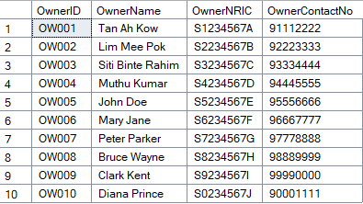

Customer Table:
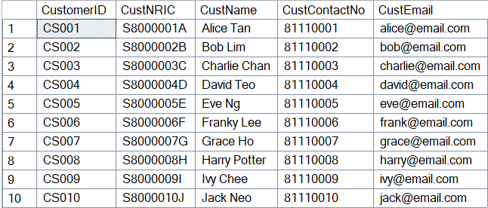

NEA_Officer Table:
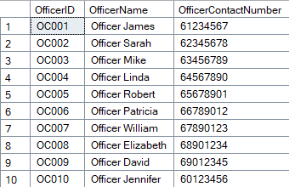

Cuisine Table:
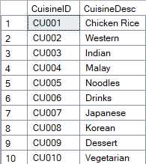

FoodStall Table:
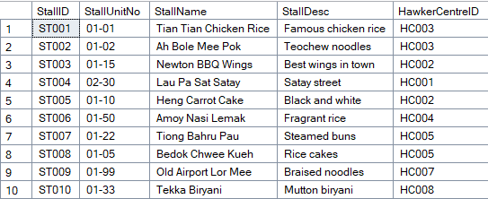

CustOrder Table:
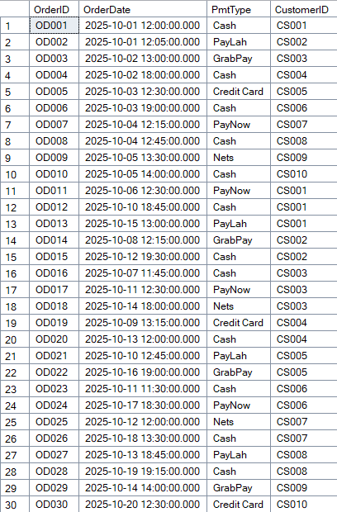

MenuItem Table:
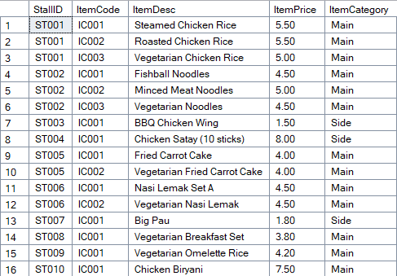

RentalAgreement Table:
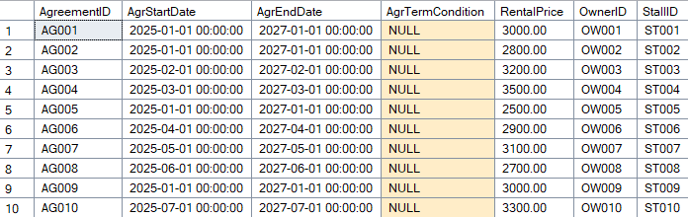

Inspection Table:
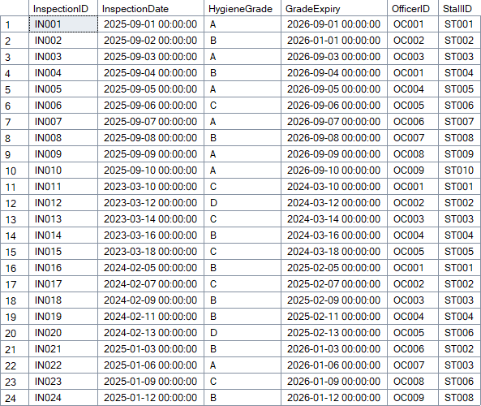
Feedback Table:
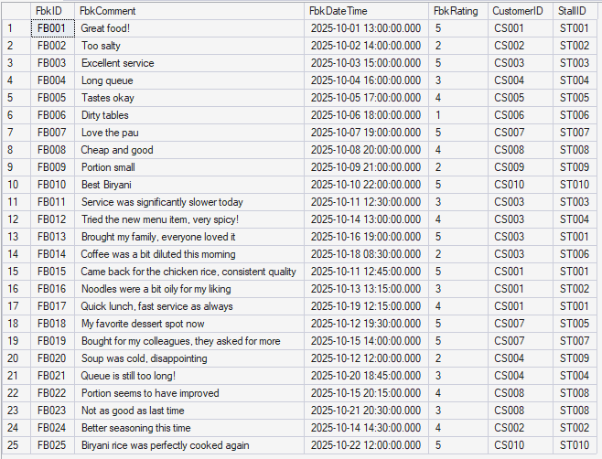

OrderItem Table:
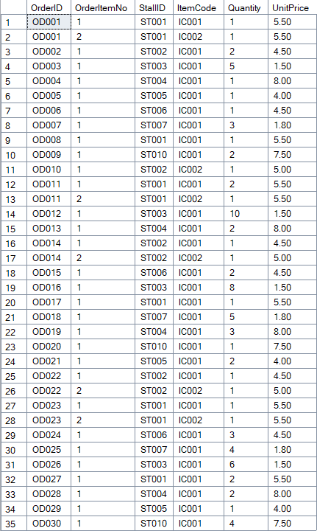

MenuItemCuisine Table:
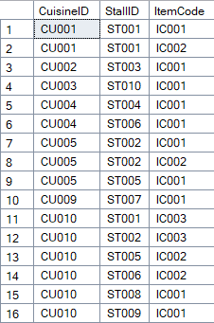

InspectionRemark Table:
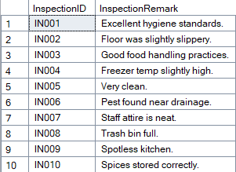

Complaint Table:
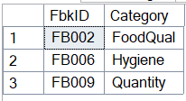

Likes Table:
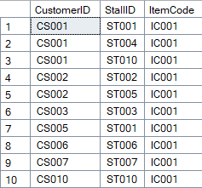

Promotion Table:
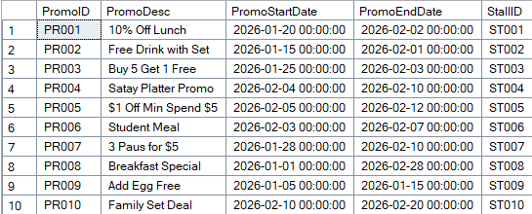

SQL Queries

Ashton

FoodStalls that has RAs expiring soon
The following SQL query is used to track the Rental Agreement of each stall before they expire; this allows the business to quickly inform the Owner to reapply for another Rental Agreement when approaching the due date.

English Query
List the HawkerCentreID, Hawker Centre Name, StallID, StallName, StallUnitNo, Agreement End Date and Months until the Agreement expires, calculated by subtracting the Month of the Agreement End Date and the Month of the Current Date. With the number of months being ordered in ascending order.

SQL Query
SELECT hc.HawkerCentreID, hc.HCName AS 'Hawker Centre Name', fs.StallID, StallName, StallUnitNo, AgrEndDate,
DATEDIFF(MONTH,GETDATE(), AgrEndDate) AS 'Months till expired' FROM FoodStall fs INNER JOIN HawkerCentre hc
ON fs.HawkerCentreID = hc.HawkerCentreID
INNER JOIN RentalAgreement ra ON fs.StallID = ra.StallID
ORDER BY [Months till expired] ASC, hc.HawkerCentreID ASC, fs.StallID ASC
GO

Output
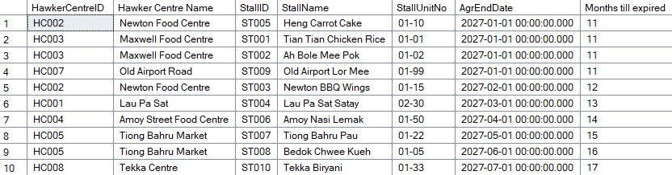

Total Rental Payment for Each Food Stall
The SQL Query below shows the total rental payment for each food stall up to the current day. This is to allow the business to ensure that the Owner of the food stall has paid the correct rent amount, which can help to ease the tracking of payments, reducing confusion and enabling the business and their stakeholders to make more accurate financial decisions.

English Query
List the Hawker Centre ID, StallID and Total Rent Payment to pay till the current date, order them from lowest to highest amount.

SQL Query
SELECT hc.HawkerCentreID, fs.StallID, RentalPrice*DATEDIFF(MONTH, AgrStartDate, '11/01/2023') AS "Total Payment" FROM FoodStall fs INNER JOIN HawkerCentre hc
ON fs.HawkerCentreID = hc.HawkerCentreID
INNER JOIN RentalAgreement ra ON fs.StallID = ra.StallID
ORDER BY hc.HawkerCentreID, fs.StallID ASC

Output
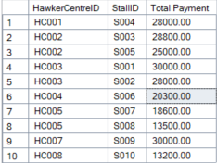

FoodStalls that are doing well and Rent for each stall
The SELECT query below shows the food stalls that have an estimated revenue of more than $1000 per month, along with the stall’s rent amount. This can allow the business to adjust the rent amount according to the revenue generated, allowing for more potential revenue to be generated by the business. Moreover, the business could also check if they are overcharging stalls, reducing rent prices so that the stall owners could afford and pay on time, ensuring that the business is able to still gain rental income.

English Query
List StallID, StallName and Rental Price of Stalls that has a estimated revenue of more than $1000 per month, sort by descending order based on the estimated revenue for the month.

SQL Query
SELECT fs.StallID, StallName, ra.RentalPrice, SUM(UnitPrice*Quantity)*30
AS "Estimated Revenue for the Month" FROM FoodStall fs
INNER JOIN RentalAgreement ra ON fs.StallID = ra.StallID
INNER JOIN OrderItem oi ON fs.StallID=oi.StallID
GROUP BY fs.StallID, StallName, ra.RentalPrice
HAVING SUM(UnitPrice*Quantity)*30 >1000
ORDER BY [Estimated Revenue for the Month] DESC

Output
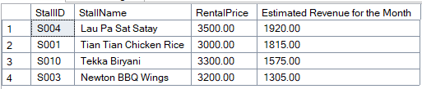

Jaether

Total Sales Revenue by Payment Type
The query below analyzes customers’ preferred payment methods and their contribution to the overall revenue. This helps operators understand which payment channels are the most used among paying customers. From a business point of view, since cash is the most popular, stall owners can ensure their staff are trained to handle cash and have sufficient change for peak periods. Since Credit Card users spend the most among all payment types, they can create premium menu items to target Credit Card users and earn more money. This also directly leads to the provision of faster service and better hygiene, since stall staffs would not have to touch the cash. Operators can also implement incentives to encourage payment through these cashless channels.

English Query
List payment methods used by customers, total number of orders, total items ordered, total revenue generated, and average item value for each payment method. Sorted in descending order by total revenue.

SQL Query
select
co.PmtType as "PaymentMethod",
count(distinct co.OrderID) as "TotalOrders",
count(oi.OrderItemNo) as "TotalItems",
sum(oi.Quantity*oi.UnitPrice) as "TotalRevenue",
round(avg(oi.Quantity*oi.UnitPrice), 2) as "AvgItemValue"
from CustOrder co inner join OrderItem oi on co.OrderID = oi.OrderID
group by co.PmtType
order by “TotalRevenue” desc;

Output
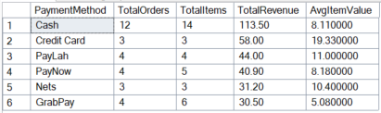

Top spending Customers
This query shows the customers who contributed the most to the hawker centre’s revenue. This allows Operators to consider and implement loyalty programs to reward these customers. To grow the business, they could create loyalty programs where customers could, for example, get a 5% discount if they order 2 set meals from a stall, get rewards for coming back to the hawker centre on the 10th visit, or even a free meal on their birthdays.

English Query
List the top 5 customers by their respective total spending. Include their ID, name, number of orders placed, total items purchased, total spending, and average order price. Sort by total spending in descending order.

SQL Query
select top 5 c.CustomerID, c.CustName,
count(distinct co.OrderID) as "NumOfOrders",
sum(oi.Quantity) as "ItemsPurchased",
sum(oi.Quantity*oi.UnitPrice) as "TotalSpending",
round(avg(oi.Quantity * oi.UnitPrice),2) as "AvgOrderPrice"
from Customer c
inner join CustOrder co on c.CustomerID = co.CustomerID
inner join OrderItem oi on co.OrderID = oi.OrderID
group by c.CustomerID, c.CustName
order by “TotalSpending” desc;

Output
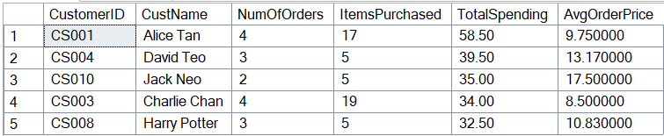

Average Number of Items per Order by Customer
This query reveals Customers’ ordering patterns by calculating the number of items customers usually buy in an order. This helps Operators understand the customer’s buying behaviour and come up with promotions such as bundles and combo deals. From a business point of view, there is potential to scale up on upselling opportunities and bundles. Upselling would target customers who would usually get just one item. Staff can be trained to offer sides or good pairings for the item the customer had just picked. While value meals and limited-time bundles could also help see an increase in this area. For example, have more combinations of food items (Set A: main + drink, Set B: main + side + drink) and Dinner set special bundles (6pm-7.30pm: Any main + drink for $7.50). These strategies all encourage customers to order more items and spend more at the hawker centre.

English Query
List the top 5 customers who ordered the greatest number of items per transaction. Show their ID, name, total number of orders, and average number of items per order. Sort by average number of items per order in descending order.

SQL Query
select top 5 c.CustomerID, c.CustName,
count(distinct co.OrderID) as "NumOfOrders",
count(oi.OrderItemNo) as "NumOfItemsOrdered",
round(count(oi.OrderItemNo) * 1.0 / count(distinct co.OrderID), 2) as "AvgItemsPerOrder"
from Customer c
inner join CustOrder co on c.CustomerID = co.CustomerID
inner join OrderItem oi on co.OrderId = oi.OrderID
group by c.CustomerID, c.CustName
order by “AvgItemsPerOrder” desc;

Output
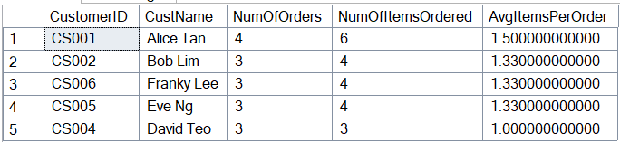

Yi Shen

Stall Cuisines and Information
This query allows people to search a stall they may be interested in, and get the menu items of that stall, and its information, including Item Name, Price, Category (Side/Main), and its Cuisine. This helps to see if they would like to purchase food from that stall, or rather if the food fits to their tastes.

English Query
List the item names, prices, item categories and cuisines of a certain stall. Sort the table by ascending item names.

SQL Query
SELECT mi.ItemDesc as 'Item Name', mi.ItemPrice as 'Price', mi.ItemCategory as 'Category', cu.CuisineDesc as 'Cuisine'
FROM MenuItem mi
INNER JOIN MenuItemCuisine mic ON mi.StallID = mic.StallID AND mi.ItemCode = mic.ItemCode
INNER JOIN Cuisine cu ON mic.CuisineID = cu.CuisineID
WHERE mi.StallID IN
(SELECT st.StallID FROM FoodStall st WHERE StallDesc LIKE '%%')
ORDER BY mi.ItemDesc ASC
GO

Output
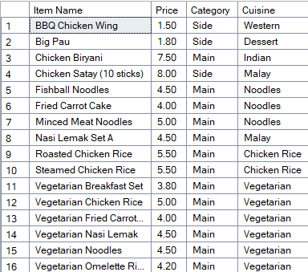

Ongoing Promotions
This query allows customers to see what promotions are being held at the stalls to potentially save money on items. Giving this information to customers actually benefits food stall owners, since holding promotions now attracts customers even further now that promotions are more obvious.

English Query
List the Stall Names that have promotions, their respective promotions and how long until the promotion ends. All promotions listed must be active today.

SQL Query

SELECT st.StallName as 'Stall Name', p.PromoDesc as 'Promotion', DATEDIFF(DAY, GETDATE(),p.PromoEndDate) as 'Number of days left'
FROM FoodStall st
INNER JOIN Promotion p ON st.StallID = p.StallID
WHERE GETDATE() BETWEEN p.PromoStartDate AND p.PromoEndDate
GO

Output (As of 1 February)
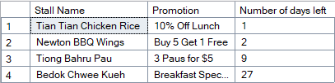

Vegetarian Inclusivity for Customers
Since some customers must eat vegetarian food for possible health or religious purposes, it would be useful for them to know what menu items in the hawker centre are vegetarian, so they can eat safely. It also lists information just like in the first query.

English Query
List the stall names, item names, prices and categories (side/main) of each food item that is vegetarian. Sort items by ascending stall id.

SQL Query
SELECT st.StallName as 'Stall Name', mi.ItemDesc as 'Item Name', mi.ItemPrice as 'Price', mi.ItemCategory as 'Category'
FROM MenuItem mi
INNER JOIN FoodStall st ON mi.StallID = st.StallID
INNER JOIN MenuItemCuisine mic ON mi.StallID = mic.StallID AND mi.ItemCode = mic.ItemCode
WHERE mic.CuisineID =
(SELECT CuisineID FROM Cuisine WHERE CuisineDesc = 'Vegetarian')
ORDER BY mi.StallID ASCName

Output
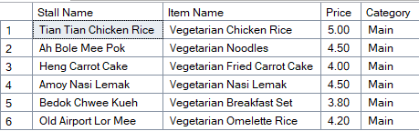

Lakshya

Stalls with expired hygiene grades
After an inspection, a stall gets 6-12 months. However, NEA does not automatically know when the grade expires. Thus, they need to actively track it. Thus, this query finds all the food stalls that are currently operating with expired hygiene certificates.

English Query
List all food stalls that are currently operating with expired hygiene certificates. List their stall name, which hawker centre they're in, what grade they had, when it expired, and how many days overdue they are. List the most overdue stalls first .

SQL Query
SELECT
fs.StallID, fs.StallName, hc.HCName AS HawkerCentre, i.HygieneGrade, i.GradeExpiry, DATEDIFF(DAY, i.GradeExpiry, GETDATE()) AS DaysExpired
FROM FoodStall fs
INNER JOIN HawkerCentre hc ON fs.HawkerCentreID = hc.HawkerCentreID
INNER JOIN Inspection i ON fs.StallID = i.StallID
WHERE i.GradeExpiry < GETDATE()
ORDER BY DaysExpired DESC;
GO

Output
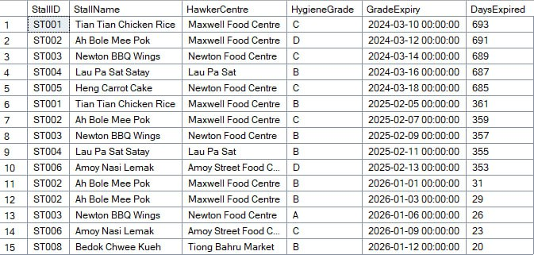

Operators with best Stalls
This compares all the operators to see who’s doing the best job maintaining the hygiene standards. This is so to identify those stalls that are doing well in terms of hygiene.

English Query
Compare all the hawker centre operators and tell me how many centres each one manages and how many of their stalls have Grade A hygiene ratings. I want to see which operators are maintaining the best hygiene standards across their centres.

SQL Query
SELECT hc.HawkerCentreID, hc.HCName, o.OperatorName,
(SELECT COUNT(DISTINCT fs1.StallID) FROM FoodStall fs1
INNER JOIN HawkerCentre hc1 ON fs1.HawkerCentreID = hc1.HawkerCentreID
INNER JOIN Inspection insp1 ON fs1.StallID = insp1.StallID
WHERE hc1.HCName = hc.HCName
) AS CentersManaged,
(SELECT COUNT(DISTINCT fs1.StallID) FROM FoodStall fs1
INNER JOIN HawkerCentre hc1 ON fs1.HawkerCentreID = hc1.HawkerCentreID
INNER JOIN Inspection insp1 ON fs1.StallID = insp1.StallID
WHERE insp1.HygieneGrade = 'A' AND hc1.HCName = hc.HCName
) AS GradeAStalls
FROM HawkerCentre hc
INNER JOIN Operator o ON hc.OperatorID = o.OperatorID
INNER JOIN FoodStall fs ON hc.HawkerCentreID = fs.HawkerCentreID
INNER JOIN Inspection i ON fs.StallID = i.StallID
WHERE i.GradeExpiry >= GETDATE()
GROUP BY hc.HawkerCentreID, hc.HCName, o.OperatorName
HAVING COUNT(DISTINCT fs.StallID) >= 2
ORDER BY CentersManaged DESC;
GO

Output

List stalls with Grade C
This query lets operators see what stalls have been graded a ‘C’, which means that it needs to be more regularly checked on.

English Query
List the Stall Name, Stall ID, Hawker Centre and Operator of all Inspections with ‘C’ grade.

SQL Query
SELECT
fs.StallID, fs.StallName, hc.HCName, o.OperatorName, i.InspectionDate, DATEDIFF(DAY, i.InspectionDate, GETDATE()) AS DaysSinceInspection
FROM FoodStall fs
INNER JOIN HawkerCentre hc ON fs.HawkerCentreID = hc.HawkerCentreID
INNER JOIN Operator o ON hc.OperatorID = o.OperatorID
INNER JOIN Inspection i ON fs.StallID = i.StallID
WHERE i.HygieneGrade = 'C'
ORDER BY i.InspectionDate DESC;
GO

Output
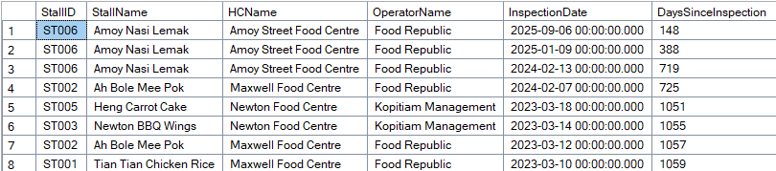

Sairam

Find Stalls by Average Customer Rating
This query will identify the top-performing stalls based on customer sentiment by calculating the average satisfaction rate for customers per stall. This will aid the Hawker Centre Operator audit the quality across the premises. From a business point of view, stalls with high ratings could be awarded with a “Stall of the Month” recognition to boost morale and marketing. At the other end, stalls with low average ratings could be flagged for intervention and can then be reviewed by management to decide whether to send the stall owners for customer service training to ensure that the overall reputation of the hawker center remains high.

English Query
List the name of the food stalls and their calculated average feedback rating. Results are rounded to two decimal places and sorted in descending order by the average rating to highlight the best performers first.

SQL Query
SELECT
S.StallName,
ROUND(AVG(F.FbkRating), 2) AS "AverageRating"
FROM FoodStall S
INNER JOIN Feedback F ON S.StallID = F.StallID
GROUP BY S.StallName
ORDER BY "AverageRating" DESC;

Output
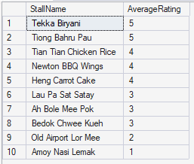

Most Active Customers by Feedback Volume
This query will identify customers who are the most active in providing feedback to the system. This would allow the marketing and operations teams of the Hawker Centre to engage their most vocal and feedback-providing customers. From a business perspective, these customers would be ideal people to call for beta-testing new launches (e.g. Ordering App) or invite for food tasting events, as they are already very engaged. On top of that, if there are customers who are frequently leaving bad feedback, management can prioritise their issues to prevent them from spreading bad word-of-mouth.

English Query
List the customer names and the total count of reviews they have submitted. The list is filtered to only show customers who have submitted more than one review. Sort by the total number of reviews in descending order.

SQL Query
SELECT
C.CustName,
COUNT(F.FbkID) AS "TotalReviewsGiven"
FROM Customer C
INNER JOIN Feedback F ON C.CustomerID = F.CustomerID
GROUP BY C.CustName
HAVING COUNT(F.FbkID) > 1
ORDER BY "TotalReviewsGiven" DESC;

Output
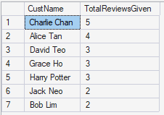

Dealing with Below-Average Feedback from Customers
This query will isolate specific feedback entries where the rating falls below the current average standard of the hawker centre. This will allow Operations to focus on the specific stalls that need assistance with this feedback. From a business standpoint, a fixed benchmark may not always be accurate (e.g. 3 stars). By filtering for ratings lower than the overall average, management can quickly identify negative incidents, read comments to understand the root cause and take corrective action to retain those customers.

English Query
List the stall name, the specific feedback comment, and the rating given for all feedback entries where the rating is strictly lower than the overall average rating of all feedback in the system. Sort by rating in ascending order (lowest ratings first).

SQL Query
SELECT
S.StallName,
F.FbkComment,
F.FbkRating
FROM Feedback F
INNER JOIN FoodStall S ON F.StallID = S.StallID
WHERE F.FbkRating < (SELECT AVG(FbkRating) FROM Feedback)
ORDER BY F.FbkRating ASC;

Output

